ECE 540 FINAL PROJECT PROPOSAL

Project Name: Labyrinth

Engineer 1: Hoa Quach

Engineer 2: Mark Ronay

Engineer 3: Colten Nye

Project Description [what are you going to build? What are your inputs/outputs? What component(s) will you use? What tools will you use?]:

We propose to build a video game using the accelerometer on the Nexys4 as a controller and displaying the output via VGA. Our input would be the accelerometer and our output would be VGA. A picoblaze microprocessor would control elements of the game.

The game would be an adaptation of Project 2; instead of a “bot” controlled by buttons or program, there would be a “ball” controlled by the tilt of the board. A simple scheme would be used where the ball does not turn, but simply updates its position on an X,Y grid based on accelerometer inputs. The steeper the angle of tilt measured by the accelerometer the faster the motion of the bot in the appropriate directions.

Points could be assigned in the game in one of two ways: Either there could be a final destination where the player tries to get the bot to one of multiple goal points worth verying amount or the player could try to follow a line without deviating, with points being given/taken for staying on/failling off the line.

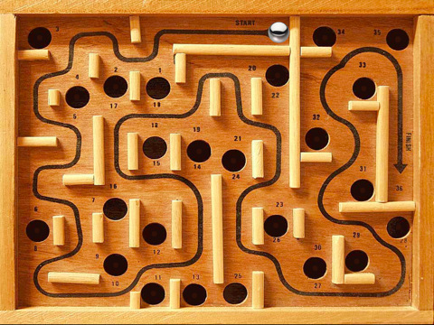

The graphics could be a simple overhead 2d view with a ball icon and the score. More elaborately, I think it would be possible to make a pseudo 3D map which tilts as the board tilts using a graphics technique called “billboarding’. This technique uses a 2d image and then applies a transform to the pixels to create one point perspective from a sequence of focal points. Pixel maps would be generated in a program like Matlab and imported into a V file. A state machine would then take input from the accelerometer and display one of the map graphics with one point perspective appropriate to the board orientation. The bot graphic would be similarly transformed and its X,Y coordinates appropriately mapped to keep it on the surface of the map. This would be a significant added layer of complexity, but would look really impressive.

We aren’t sure at this point if it would be easier to start from project 2 and adapt the bot to our purposes, or to make a new bot from scratch. The bot would need to update its position based on accelerometer input and points would need to be assessed based on location. Could these operations be done purely in hardware, allowing us to forgo the use of a picoblaze in the ball module?

Design Approach [How are you going to build it? how will you demonstrate success on the FPGA Development Board? what are your options if you start running out of time?]:

As a group we will define an overall design heirarchy and diagram, including named input/outputs between modules. One person figures out how to get output from the accelerometer. One person figures out basic full 2d graphics largely done in the existing maps. One person writes the interface. Between these three tasks it should be possible to make an icon move on a map with the input from the accelerometer.

From there we can add a scoring system and the advanced graphics outlined above.

Aspects that could be ommited if we run low on time could be:
- Advanced graphics
- Scoring overlay
- Degree-of-tilt scaled roll speed
- End game / new game
- Any sort of scoring

Milestones/Deliverables [How are you going to demonstrate that you’re making progress]:

Week of 11/23: Define and assign project tasks and schedule

Week of 11/30 : Board tilt is rolling a ‘ball’ around an empty map

Week of 12/7: Demonstration and Final Report

